TRADE OF
Pipefitting

PHASE 2

Module 5

Technical Drawing

UNIT: 1

Drawing Methods and Types

Produced by

In cooperation with subject matter expert:

Finbar Smith

© SOLAS 2014
Table of Contents
Unit Objective 1
Learning Outcome 2
1.0 Presentation of Drawings 3
1.1 Function of Drawings 3
1.2 Format of Drawings 3
2.0 Drawing Views and Perspectives 5
2.1 Orthographic Projection 5
2.2 Isometric Projection 6
2.3 Parallel Line Development 7
2.4 Radial Line Development 8
Exercises 9
Additional Resources 10

Unit Objective
There are five units in Module 5. Unit 1 focuses on Drawing Methods & Types, Unit 2; Standard Drawing Conventions, Unit 3; Drawing Equipment & Practice, Unit 4; Drawings for Piping Installation, Unit 5; Traceability Record.
In this unit you will be introduced drawing methods and types.
Module 5

Technical Drawing
Unit 1

Drawing Methods & Types
Unit 2

Standard Drawing Conventions
Unit 3

Drawing Equipment & Practice
Unit 4

Drawings for Piping Installation
Unit 5

Traceability Record

Learning Outcome
By the end of this unit each apprentice will be able to:
- Identify the function of drawings
- Identify the different formats of drawings used in the pipefitting industry.
- State the different methods of presenting drawings to pipefitters.
- Identify the methods for displaying different views on technical drawing

1.0 Presentation of Drawings

Key Learning Points
- Identify the function of engineering drawings
- List the different type of drawings used in the pipefitting industry.
- Identify what the different drawings are used for.
A basic understanding of engineering prints and drawings is necessary for pipefitters and maintenance personnel to install and safely maintain pipework within a facility. The following information is presented to provide a basic foundation in drawing for applying engineering concepts to piping projects.

1.1 Function of Drawings
Technical drawing is also referred to as the "language of sight". It can be learnt to illustrate objects, functions or arrangements unambiguously and clearly. The main function of a drawing is to transfer information from the design team to the construction team and present the information in a user friendly legible format. Depending on the information to be transferred drawings can range from a simple hand sketch to a detailed 3D model. The following list identifies the types of drawings commonly used in the pipefitting industry:
- Architectural / Civil drawings
- General arrangement GA drawings
- Isometric spool drawings
- Free hand sketch
- Standard detail drawings
- 3D model

1.2 Format of Drawings
Architectural / Civil drawings: Architectural drawings present information about the conceptual design of the building or structure. Examples are civil plans of a facility, building elevations (outside view of each side of a structure), foundation drawings, and sectional elevation drawings showing finished floor levels, main pipe rack levels and finished ceiling levels.
General arrangement (GA) drawings: are orthographic views of the overall facility which show the inter relationship the equipment and piping with the Architectural / Civil drawings. They are usually the controlling reference documents from which the other piping drawings are derived from. The GAs are also used by the other crafts such as the electricians to plan their work such as routing conduit, instrument tubing or electrical bundles.
Isometric drawings: are derived from the GA drawings and are used to subdivide a piping system into smaller manageable spools which are suitable for pre-fabrication. For high purity systems which require weld traceability these drawings are usually used as weld maps to record the positions of welds and what welder completed them.
Free hand sketches: often used in the field to convey or clarify minor points of information between engineers and pipe fitters. Pipe fitters also need to know how to draw free hand sketches as they may need to bring information back to update system drawings with changes that were made in the field.
Standard detail drawings: These drawings are used to detail standard recurring requirements such as ope penetrations, bracketing support or anchor details. These drawings would be agreed with the client and kept in a central file for reference when ever required.
3D Models: The advent of computers and CAD packages have allowed designers to model the complete building, process equipment and interconnecting pipework.

2.0 Drawing Views and Perspectives

Key Learning Points
- Identify the different types of views used to present drawings
- Identify what orthographic projection drawings are
- Identify what isometric drawings are
- Identify what parallel line development drawings are
- Identify what radial line development drawings are
In addition to the different drawing formats, there are different views or perspectives in which the formats can be drawn. The most commonly used are the orthographic projection and the isometric projection.

2.1 Orthographic Projection
Orthographic projection is widely used for fabrication and construction type drawings, as shown in Figure 1. Orthographic projections present the component or system through the use of three views, These are a top view, a side view, and a front view. Other views, such as a bottom view, are used to more fully depict the component or system when necessary.
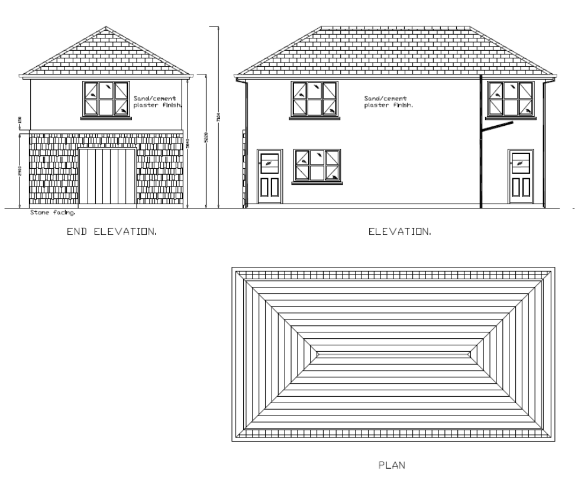
Figure 1 – Typical orthographic representation of a building

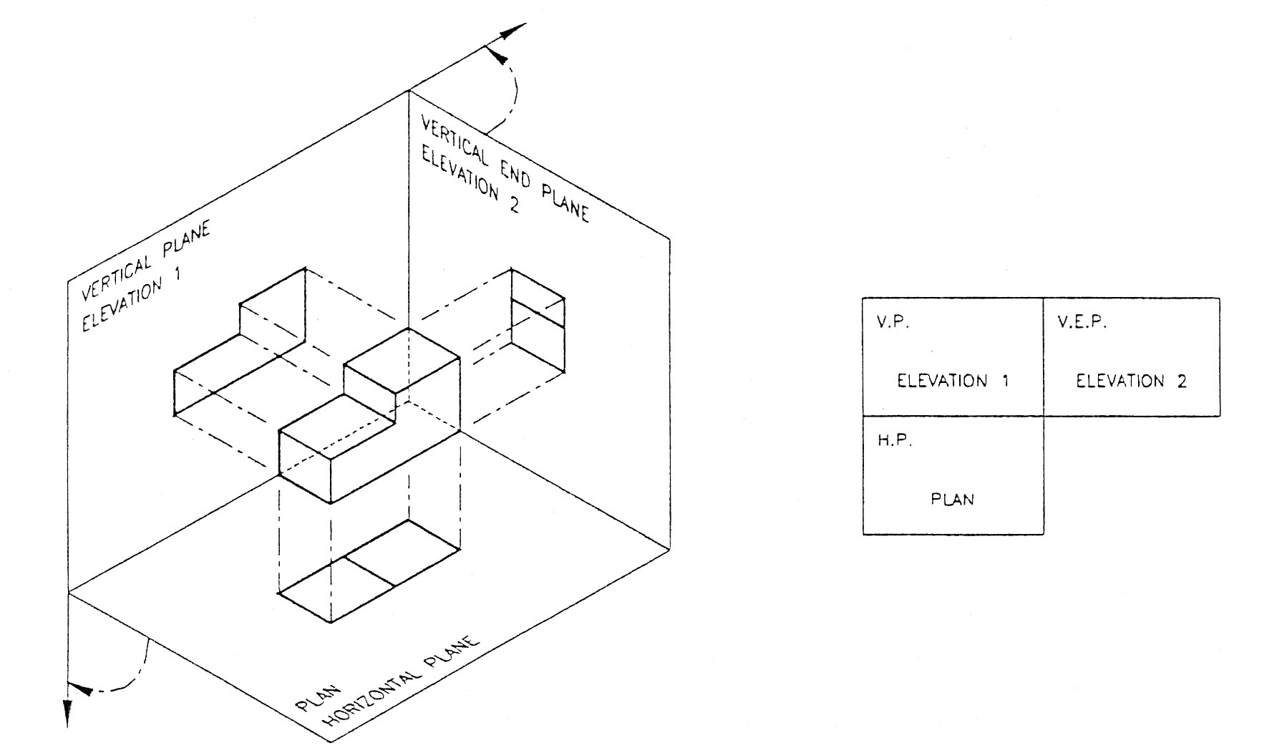
Figure 2 shows how each of the three views is obtained. The orthographic projection is typically drawn to scale and shows all components in their proper relationships to each other. The three views, when provided with dimensions and a drawing scale, contain information that is necessary to fabricate or construct the component or system.

Figure 2 –Orthographic projection of 3 views of a solid object

2.2 Isometric Projection
The isometric projection presents a single view of the component or system. The view is commonly from above and at an angle of 30°. This provides a more realistic three dimensional view. As shown on Figure 3, this view makes it easier to see how the system looks and how its various portions or parts are related to one another. Isometric projections may or may not be drawn to a scale.
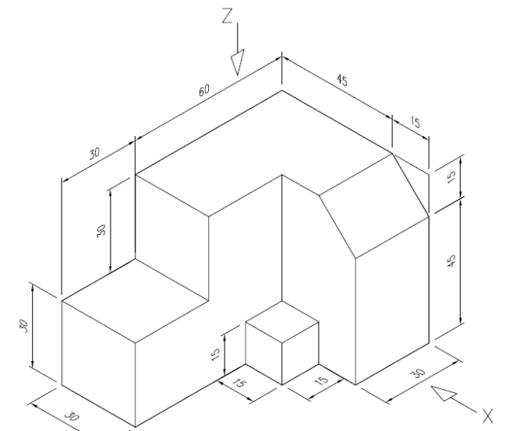
Figure 3 –Isometric drawing of a solid object

Isometric drawings are commonly used to give clarity to complicated pipe spools with a lot of detail and different piping components. Before the introduction of CAD these were normally completed as line isometrics as seen in Figure 4a, however with proficient use of 3D CAD packages which have extensive component libraries it is a relatively simple task to complete a pictorial isometric as illustrated in Figure 4b.

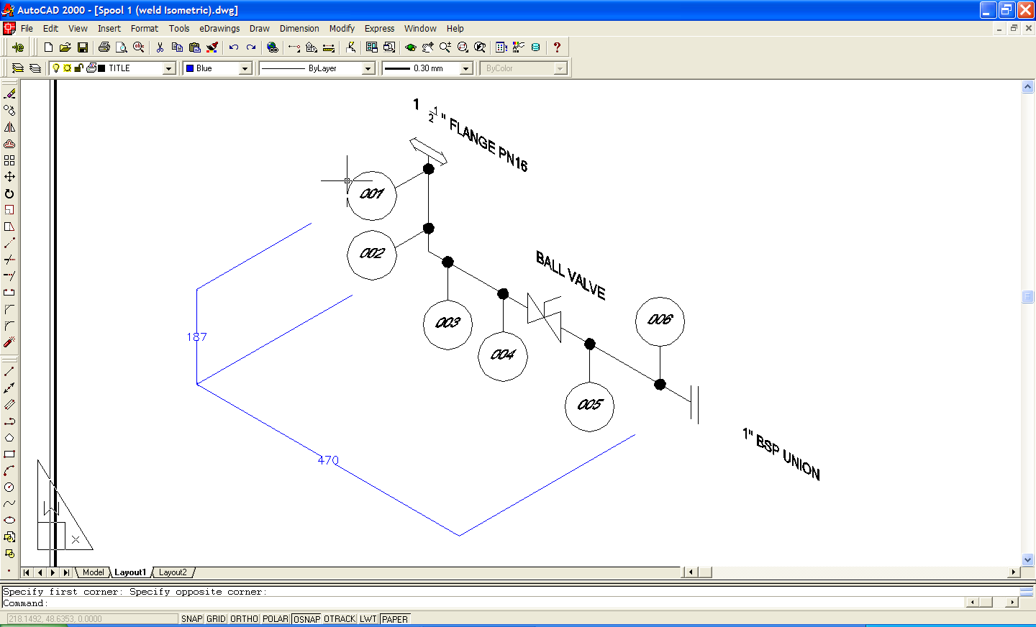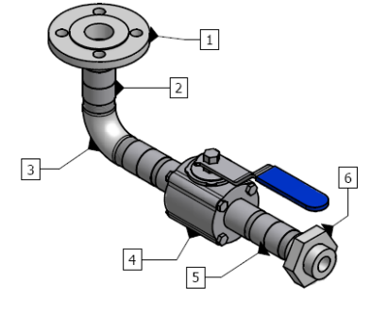
Figure 4a –Line isometric of pipe spool. Figure 4b Pictorial isometric of pipe spool

2.3 Parallel Line Development
Parallel line development is used to develop patterns of square, rectangular and cylindrical shapes (prisms). The method divides the surface into a series of parallel lines to determine the shape of a pattern. Figure 5 below illustrates how the parallel line development of a truncated cylinder is developed.
The circumference of the circle is divided into 12 equal spaces which is stretched out in the right hand view. The parallel lines give us the chord lengths which are projected over to the stretch out chords, which represent chords on the circumference of the cylinder. This gives us a series of heights which are joined by freehand to give a true shape development of the surface of the cylinder. Essentially it is 'unfolding' the cylindrical shape from three dimensions into two dimensions.
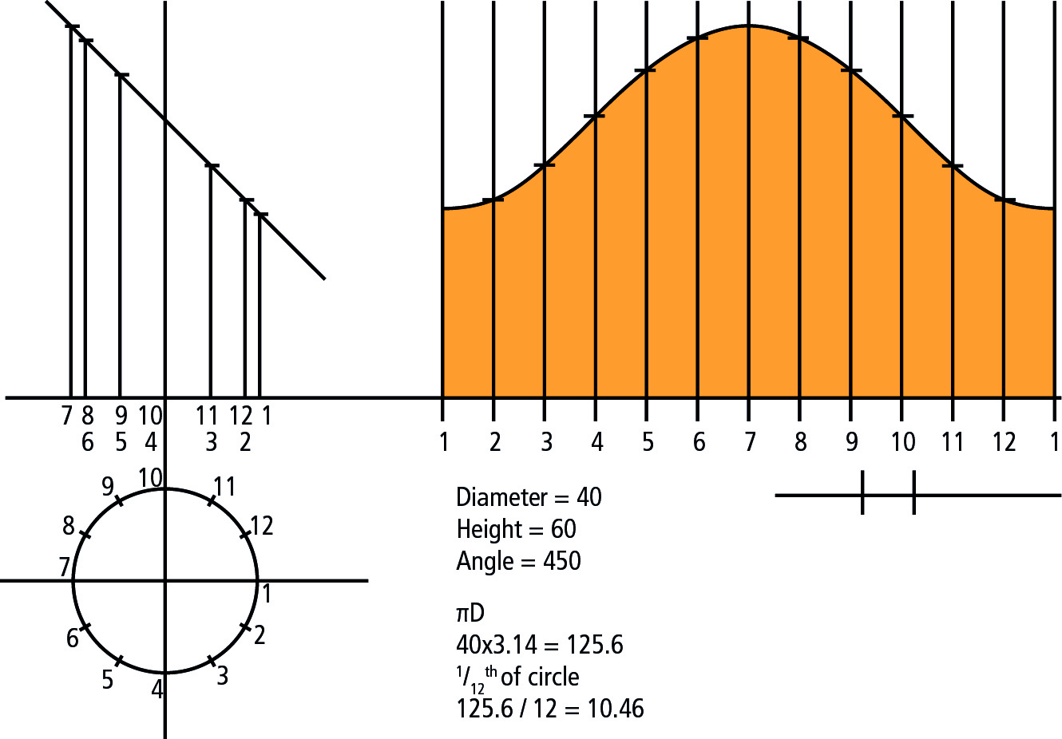
Figure 5 –Parallel line development of a truncated cylinder

Parallel line development is used for the pattern development of pipe work, prisms, and any cylindrical shape. Pattern development can be marked directly onto flat metal plate. The metal is then formed to shape. Patterns are often turned into templates using paper or thin sheet steel. On formed stock pipe, the pattern becomes a wrap around template, and can be used over and over again. Often with cylindrical pipe work, the sizes are outside the range of available stock pipe. In that case, the cylinder must be formed from flat plate, using the pattern to establish the required shape.

2.4 Radial Line Development
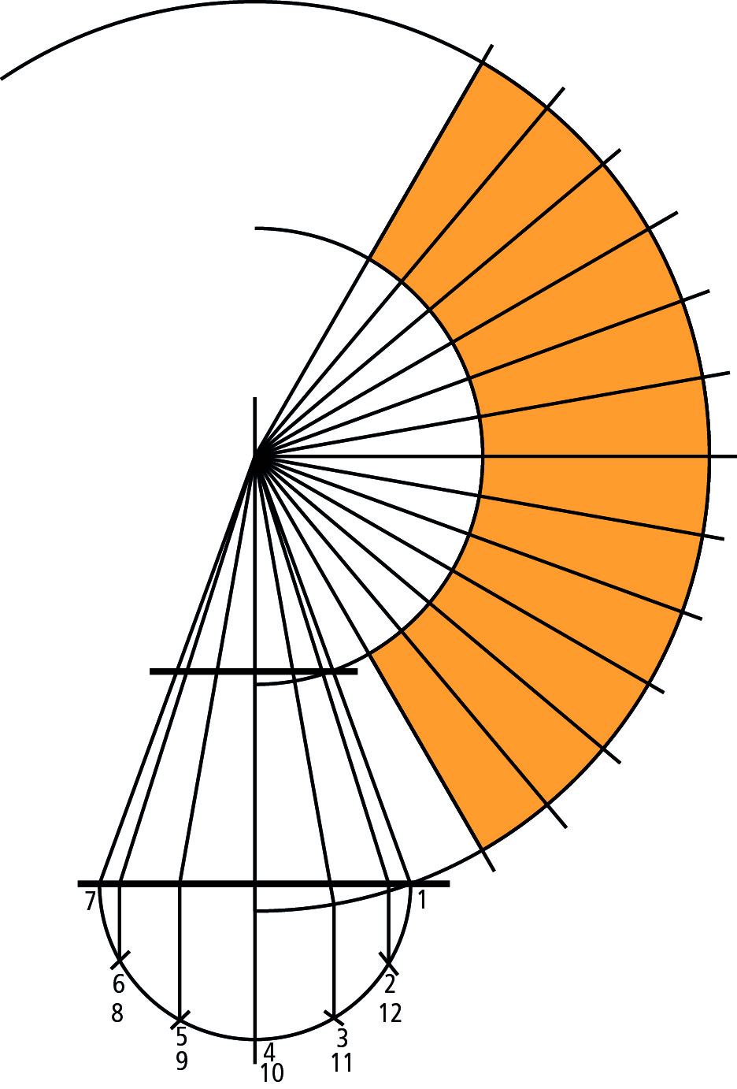
The radial line method of pattern development is used to develop patterns for objects that have a tapering form with lines converging to a common point, called the apex point. The radial line method uses a series of radial generator lines drawn from a common apex point to develop a specified pattern or shape. Radial line development is used for conical shapes, that is, where a shape converges to an apex point (at a workable distance).

Figure 6 –Radial line development of a truncated cone
Figure 6 above illustrates how the radial line development of a truncated cone is completed. Two arcs are drawn using the apex as the centre point and the base of the cone as the external radius and the base of the truncated cone as the internal radius. The cone is divided into 12 equal spaces which are marked 12 times along the larger arc. These are then joined to the apex to give a true shape development of truncated cone surface. This method of drawing is often used for the development of patterns for pipe reducers or large conical hoppers.

Exercises
- Hand sketch 3 orthographic views of a desk.
- Draw and cut out the parallel line development for a cylinder of diameter 60mm which is truncated at 45º to its axis.

Additional Resources
Title | Author | Ref. Code
The Induction Book, “Code of Behaviour & Health & Safety Guidelines” | SOLAS
Basic Welding and Fabrication | W Kenyon | ISBN 0-582-00536-L
Fundamentals of Fabrication and Welding Engineering | FJM Smith | ISBN 0-582-09799-1
Workshop processes, practices and materials, 3rd edition, Elsevier Science & Technology | Black, Bruce J 2004 | ISBN-13: 9780750660730
New Engineering Technology | Lawrence Smyth & Liam Hennessy | ISBN 086 1674480

Videos:
- Understanding welding fumes
- Welder on Site…Be Aware (Vocam)
- Powered hand tool safety (Vocam)
- Industrial Ergonomics (Vocam)
Available from:
Vocam Ireland
Circle Organisation Ltd
Friar Street, Thurles, Co Tipperary, Ireland
Tel: +353 504 24666

Castleforbes House
Castleforbes Road
Dublin 1

